
Year 12 Human Biology
Unit 4: Test – Mutations and Gene Pools (5%)

TASK 8 – Test 3
Mutations & Gene Pools

Time: 60 mins

Multiple Choice: 10 marks
Short Answer: 31 marks
Extended Answer: 14 marks
TOTAL 55 MARKS

Weighting: 5%
Do not write on this question booklet
Do not turn page until instructed to do so

Section A: Multiple Choice (10 Marks)

Answer all questions by placing an X through the most correct answer on the multiple choice answer sheet.

- Below is a list of factors that may affect the evolution of gene pools.
- Mutation.
- Natural selection.
- Random genetic drift.
- Migration.
- Barriers to gene flow.

Which of the following are most likely to introduce new alleles into a gene pool?

- (i), (ii), (iii) and (v)
- (i) and (iv)
- (i) alone
- (i), (iii) and (iv)

2. Which of the following presents the best conditions to enhance random genetic drift?

(a) Large population, migration, natural selection.
(b) Small population, natural selection, migration.
(c) Large population, random mating, no mutation.
(d) Small population, no natural selection, random mating.

3. Which of the following statements about barriers to gene flow is INCORRECT?
(a) They include geographical barriers such as oceans and glaciers.
(b) They may be religious or socioeconomic in nature.
(c) They prevent the process of speciation.
(d) They increase the probability of random genetic drift occurring.

4. Mutations can be considered as one of the raw materials of evolution because they:
- contribute to new variations in organisms.
- are usually related to the environment in which they appear.
- are usually beneficial to the organism in which they appear.
- usually cause species of organisms to become extinct.

5. Genetic drift is:
- a random change in an allele due to alterations in the DNA molecule.
- a change in gene frequencies due to exchange of genes between different populations.
- a product of natural selection.
- a random change in gene frequencies from one generation to the next.

6. The high frequency of the sickle cell anemia trait in West Africa is explained by:
- genetic drift.
- the selective advantages to heterozygotes because of resistance to malaria.
- the selective advantages that accrue because of resistance to tuberculosis.
- inbreeding.

7. People who live in small island communities for a number of generations without significant immigration sometimes exhibit unusual levels of genetic diseases due to genetic mutations. This is due to:

(a) founder effect from the original settlers of the island.
(b) a diet lacking in antioxidants.
(c) high levels of radiation causing mutations.
(d) elevated levels of genetic mutations accumulating in the population.

8. Beta thalassemia:
- involves four genes and the severity of symptoms is linked to the number of genes affected.
- is a disorder of lipid metabolism which results in accumulation of fatty substances in the nervous system.
- offers resistance to malaria.
- is increased in prevalence in people around the Mediterranean coast.

9. In 1550 AD 60% of the population of the village of La Pont in France were killed by an outbreak of Plague. This altered the allele frequency of the village. This is an example of:
- random genetic drift.
- founder effect.
- genetic bottleneck.
- sociocultural isolation.

10. Which of the following is the best example of the founder effect in action?
- The last green-eyed individual in a small village community died of old age. The village population then only had blue- and brown-eyed individuals, who then reproduced only blue- and brown-eyed offspring.
- A cyclone destroyed a coastal community, killing many of the members of the local population. Over many generations the population size of the community increased to its original number, with similar genetic characteristics.
- Housing prices in an isolated country town decreased and many new families moved into the community. The new families came from a variety of different places and possessed a wider range of characteristics than those already in the town, thus greatly increasing the genetic diversity.
- Because of religious beliefs, a small group of individuals moved away from their community to live together in a new, isolated commune. Over time, the genetic characteristics of the new commune became different from those of the original larger community.


Year 12 Human Biology
Unit 4: Test – Mutations and Gene Pools (5%)

Name _________________________________________
Teacher_________________________________________

TASK 8 Mutations & Gene Pools

TOTAL / 55 MARKS

Multiple choice & answer booklet

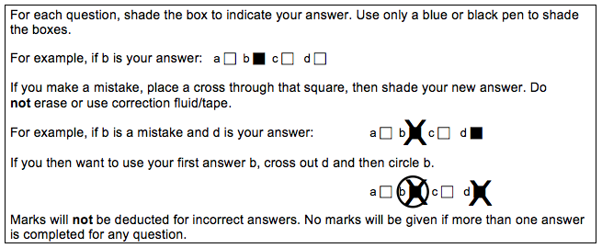

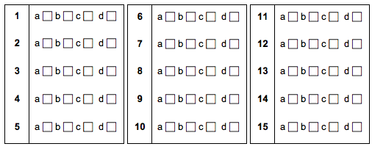
Section B: Short Answer (31 Marks)

Answer all questions in the spaces provided.
Question 11 refers to the diagram below.

FIGURE 1 KEY: A – Dominant Allele
a – Recessive Allele
a* - Mutant form of recessive allele

Figure 1 shows the changes that occurred in a population over a period of 17 years. The graph indicates changes in the size of the population and the composition of the gene pools at three difference stages are represented above the graph. (The alleles of only one gene were studied.)

- (a) For the gene pool at X, calculate the allele frequency for allele ‘a’ using the following formula (answer to 1 decimal place):
frequency of allele ‘a’ = total number of allele ‘a’ X 100
total number of alleles in population

(2 marks)

- Describe ONE way in which the population at X is similar to the population at Z.
(1 mark)

_____________________________________________________________________

_____________________________________________________________________

- Describe TWO ways in which the population at X differs from the population at Z.
(2 marks)

_____________________________________________________________________

_____________________________________________________________________

_____________________________________________________________________

_____________________________________________________________________

- Suggest ONE possible factor and explain how this accounts for the changes in the population size shown between population X and Y in Figure 1.
(2 marks)

_____________________________________________________________________

_____________________________________________________________________

_____________________________________________________________________

(e) How does the information in Figure 1 help to explain why small populations are at greater risk of extinction than larger populations?
(2 marks)
_____________________________________________________________________

_____________________________________________________________________

_____________________________________________________________________

_____________________________________________________________________

- In terms of evolution, explain how a mutation may be beneficial to a species.
(2 marks)
_____________________________________________________________________

_____________________________________________________________________

_____________________________________________________________________

_____________________________________________________________________

- There are several types of chromosomal mutations. Name two types of chromosome mutations and describe what effect they have on the chromosome. (2 marks)

TYPE | EFFECT ON CHROMOSOME

- Cystic fibrosis is caused by a gene mutation. The mutant allele for this condition is recessive but is not said to be a lethal recessive.

(a) Explain what a gene mutation is and how a child could inherit the disease.
(2 marks)
_____________________________________________________________________

_____________________________________________________________________

_____________________________________________________________________

_____________________________________________________________________

(b) Identify what could increase the likelihood of a mutation occurring. Provide an example. (2 marks)
_____________________________________________________________________

_____________________________________________________________________

(c) Describe the factors which allow for speciation to occur. (4 marks)

_____________________________________________________________________

_____________________________________________________________________

_____________________________________________________________________

_____________________________________________________________________
_____________________________________________________________________

_____________________________________________________________________

_____________________________________________________________________

_____________________________________________________________________

Question 15 refers to the information and graph below.
The peppered moth (Biston betularia) is a species of moth, found in the United Kingdom.

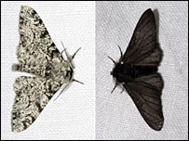

It can be found with light or dark peppered wing colouring (morphology). Below is a graph showing the frequency of the black morphology over time.
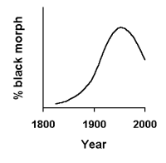
The peak in the allele frequency for black morphology occurs just before the “Clean Air Act” was passed in 1958. This act reduced the amount of smoke pollution in the United Kingdom.
- Using the correct terms explain the above change in allele frequency. (4 marks)

_____________________________________________________________________

_____________________________________________________________________

_____________________________________________________________________

_____________________________________________________________________

_____________________________________________________________________

_____________________________________________________________________

_____________________________________________________________________

_____________________________________________________________________

_____________________________________________________________________

_____________________________________________________________________

_____________________________________________________________________

- The Amish community a spiritual group which emphasize humility, family, and separation from the non-Amish world, which includes a reluctance to adopt modern conveniences such as electricity.
The current Old Order Amish population of Pennsylvania in the U.S. can be traced back to around 200 German immigrants from the 18th century. Ellis-van Creveld Syndrome is characterised by dwarfism, with very short forearms and extra fingers which are often on both hands. It is unusually prevalent among this population, present in about 1 in every 200 births compared to the general population of approximately 1 in 60,000.

(a) Describe the conditions in the Old Order Amish population to enable the founder effect to occur. (3 marks)

_____________________________________________________________________

_____________________________________________________________________

_____________________________________________________________________

_____________________________________________________________________

_____________________________________________________________________

_____________________________________________________________________

_____________________________________________________________________

_____________________________________________________________________

(b) If this community and the rest of Pennsylvania started mating, what would you predict would happen to the allele frequency for Ellis-van Creveld Syndrome over the next few generations? Explain your answer. (3 marks)

_____________________________________________________________________

_____________________________________________________________________

_____________________________________________________________________

_____________________________________________________________________

_____________________________________________________________________

_____________________________________________________________________
_____________________________________________________________________

_____________________________________________________________________

Section C: Extended Answer (14 Marks)

Answer ALL questions in the spaces provided.
- The HEXA gene codes for an enzyme that breaks down lipids found within cells, mostly in the central nervous system. If both alleles for this gene are mutated, the individual will suffer from a fatal disease called Tay-Sachs.

In Australia, the frequency of the mutated allele is very low, about 1 in 300. In the Ashkenazi Jewish population or people of Jewish decent originating from central or eastern Europe, the frequency is about 1 in 26.

Explain two factors that affect allele frequency that scientists identify could be the cause for such different gene pools. (8 marks)

- Genetic testing of natives of Iceland has indicated major differences in allele frequency to the Celts of Ireland and Scotland from where they are believed to have originated.

Describe all the possible ways in which changes in allele frequency can come about in the population in Iceland. (6 marks)
_____________________________________________________________________

_____________________________________________________________________

_____________________________________________________________________

_____________________________________________________________________

_____________________________________________________________________

_____________________________________________________________________

_____________________________________________________________________

_____________________________________________________________________

_____________________________________________________________________

_____________________________________________________________________

_____________________________________________________________________

_____________________________________________________________________

_____________________________________________________________________

_____________________________________________________________________

_____________________________________________________________________

_____________________________________________________________________

_____________________________________________________________________

_____________________________________________________________________

_____________________________________________________________________

_____________________________________________________________________

_____________________________________________________________________

_____________________________________________________________________

_____________________________________________________________________

_____________________________________________________________________

_____________________________________________________________________

_____________________________________________________________________

_____________________________________________________________________

_____________________________________________________________________

_____________________________________________________________________

_____________________________________________________________________

_____________________________________________________________________

_____________________________________________________________________

_____________________________________________________________________

_____________________________________________________________________

_____________________________________________________________________

_____________________________________________________________________

_____________________________________________________________________

_____________________________________________________________________

_____________________________________________________________________

_____________________________________________________________________
_____________________________________________________________________

_____________________________________________________________________
_____________________________________________________________________
_____________________________________________________________________

